Assignment 8

Chaiwat Plongkaew 2021326660023

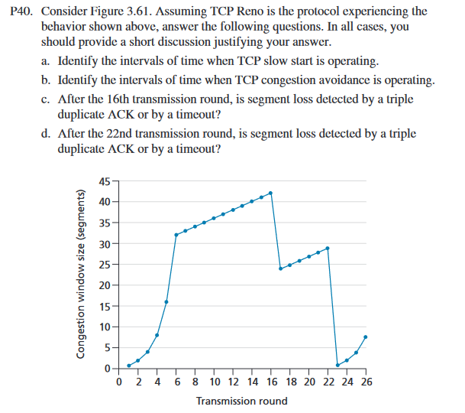

**Ans**

**a. [1,6] and [23,26]**

**b. [6,16] and [17,23]**

**c. After the 16th transmission round, packet loss is recognized by triple duplicate ACK.**

**d. After the 22nd transmission round, segment loss is detected due to the timeout, and the congestion window size would have dropped to 1.**

**e. The value of ssthresh at the first transmission round is 32.**

**f. The value of ssthresh at the 18th transmission round is 21.**

**g. The value of ssthresh at the 24th transmission round is 21.**

**h. During the 1st transmission round, packet 1 is sent; packets 2-3 are sent in the 2nd transmission round; packets 4-7 are sent in the 3rd transmission round; packets 8-15 are sent in the 4th transmission round; packets 16 to 31 are sent in the 5th transmission round; packets 32 to 63 are sent in the 6th transmission round; packets 64 to 96 are sent in the 7th transmission round. Therefore, packet 70 is sent in the 7th transmission round.**

**i. The threshold will be set to half the current value of the congestion window (8) when the loss occurred, and the congestion window will be set to the new threshold value+3 MSS. (see bottom of page 275) Thus the new values of the threshold and window will be 4 and 7 respectively.**

**j. The ssthresh and the congestion window size at the 19th round is 21 and 4.**

**k. round 17, 1 packet; round 18, 2 packets; round 19, 4 packets; round 20, 8 packets; round 21, 16 packets; round 22, 21 packets. So, in total is 52.**

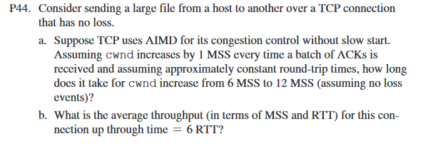

Ans

a. 1 RTTs to 7 MSS, 2 RTTs to 8 MSS, 3 RTTs to 9 MSS, 4 RTTs to 10 MSS, 5 RTTs to 11MSS, 6 RTTs to 12 MSS. Therefore, it takes 6 RTTs to 12 MSS.

b. sum of MSS: 6+7+8+9+10+11 = 51, sum of RTT: 1+1+1+1+1+1 = 6

(6+7+8+9+10+11)/6 = 9=8.5 MSS/RTT